**Scenario: A new local regional manager for Walmart contacted me to help with some data analysis of a set of 45 stores from different regions to gain some insight into the available data before jumping in to make major changes. I have been asked to answer the following based on my analysis performed in Excel.**

1. **Time of the year and weekly store sales**
2. **Prepare a line graph of the Average Weekly Sale by Week.**

**What two weeks of the year have the highest average weekly sales?** *Weeks 47 and 99 have the highest average weekly sales*

**Does this make sense? Why or why not?** *This makes sense as they both correspond to the week preceding Christmas, a major holiday in the US, for years 2010 and 2011. It means the markdown implemented by Walmart for the holidays is especially effective for Christmas.*

1. **Prepare a boxplot comparing Weekly Sales by holiday flag. Title the graph “Weekly Sales Comparison for Holiday and Non-Holiday Weeks”** 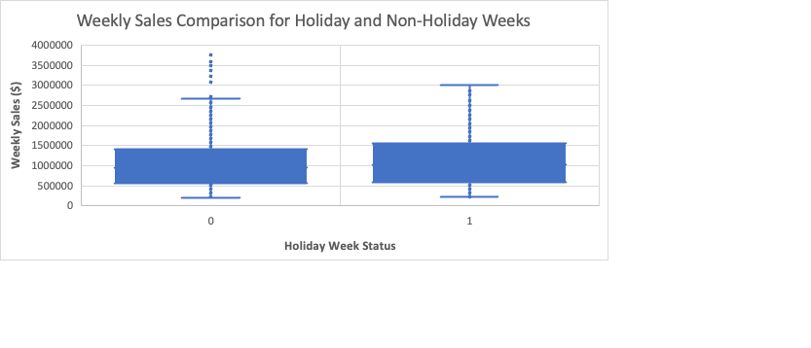
2. **What do you notice about the difference between weeks that have holidays and those that do not have holidays?**

*A comparison between the two holiday flags reveals notable distinctions. Weeks that coincide with holidays exhibit higher values for the 3rd and 1st quartiles, as well as maximum and minimum whisker points, compared to weeks without holidays. Additionally, the non-holiday weeks demonstrate a greater number of outliers, whereas the holiday weeks appear to be devoid of outliers. These observations suggest that holidays have a significant impact on the distribution and variability of the data.*

1. **Weekly sales among stores  
   a. Prepare a boxplot to demonstrate the Weekly Sales by Store.** 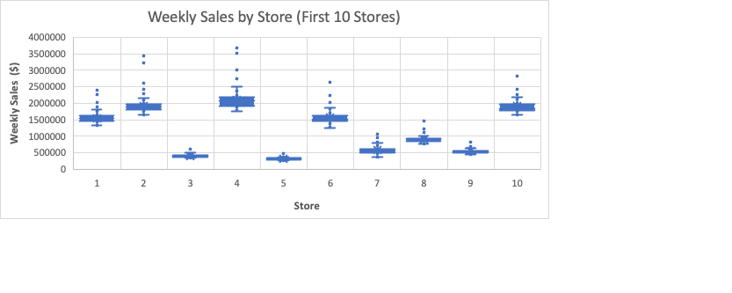

*Among the stores, the top three performing ones are Store 4, Store 2, and Store 10, while the lowest performing stores are Store 5, Store 3, and Store 9. Store 4 exhibits the highest interquartile range, indicating a larger spread of sales data and potentially more variability in performance. On the other hand, Store 5 has the lowest interquartile range, suggesting relatively consistent sales figures. Notably, all the outliers in each case are higher than the other variables, which indicates strong sales performance for those specific instances. This pattern of outliers in the higher range is considered positive for sales performance.*

**b. Provide a Bar chart showing the average weekly sales for each store.**

*Store 20 has the highest average weekly sales, while store 33 has the lowest.* **c. Provide a Table that provides the Mean, Minimum Value, Maximum Value, Median, of the weekly sales for each of the 45 stores - WALMARTBYSTORE.**

|  |  |  |  |  |
| --- | --- | --- | --- | --- |
| **Store** | **Average of Weekly_Sales** | **Max of Weekly_Sales** | **Min of Weekly_Sales2** | **Med. of Weekly_Sales** |
| 1 | 1555264.398 | 2387950.2 | 1316899.31 | 1534849.64 |
| 2 | 1925751.336 | 3436007.68 | 1650394.44 | 1879107.31 |
| 3 | 402704.441 | 605990.41 | 339597.38 | 395107.35 |
| 4 | 2094712.961 | 3676388.98 | 1762539.3 | 2073951.38 |
| 5 | 318011.8105 | 507900.07 | 260636.71 | 310338.17 |
| 6 | 1564728.186 | 2727575.18 | 1261253.18 | 1524390.07 |
| 7 | 570617.3087 | 1059715.27 | 372673.61 | 557166.35 |
| 8 | 908749.5184 | 1511641.09 | 772539.12 | 893399.77 |
| 9 | 543980.5524 | 905324.68 | 452905.22 | 536537.64 |
| 10 | 1899424.573 | 3749057.69 | 1627707.31 | 1827521.71 |
| 11 | 1356383.124 | 2306265.36 | 1100418.69 | 1323243.35 |
| 12 | 1009001.609 | 1768249.89 | 802105.5 | 981615.81 |
| 13 | 2003620.306 | 3595903.2 | 1633663.12 | 1958823.56 |
| 14 | 2020978.401 | 3818686.45 | 1479514.66 | 2004330.3 |
| 15 | 623312.475 | 1368318.17 | 454183.42 | 603318.89 |
| 16 | 519247.7301 | 1004730.69 | 368600 | 508520.09 |
| 17 | 893581.3904 | 1309226.79 | 635862.55 | 872817.62 |
| 18 | 1084718.421 | 2027507.15 | 540922.94 | 1060433.1 |
| 19 | 1444999.036 | 2678206.42 | 1181204.53 | 1408968.55 |
| 20 | 2107676.87 | 3766687.43 | 1761016.51 | 2053165.41 |
| 21 | 756069.0834 | 1587257.78 | 596218.24 | 737014.09 |
| 22 | 1028501.039 | 1962445.04 | 774262.28 | 996628.8 |
| 23 | 1389864.46 | 2734277.1 | 1016756.1 | 1358444.07 |
| 24 | 1356755.394 | 2386015.75 | 1057290.41 | 1339630.35 |
| 25 | 706721.5327 | 1295391.19 | 558794.63 | 685676.58 |
| 26 | 1002911.845 | 1573982.47 | 809833.21 | 996723.58 |
| 27 | 1775216.202 | 3078162.08 | 1263534.86 | 1731935.43 |
| 28 | 1323522.242 | 2026026.39 | 1079669.11 | 1266460.45 |
| 29 | 539451.4287 | 1130926.79 | 395987.24 | 518628.42 |
| 30 | 438579.6162 | 519354.88 | 369722.32 | 438068.71 |
| 31 | 1395901.437 | 2068942.97 | 1198071.6 | 1378340.18 |
| 32 | 1166568.155 | 1959526.96 | 955463.84 | 1144901.52 |
| 33 | 259861.692 | 331173.51 | 209986.25 | 258427.39 |
| 34 | 966781.5594 | 1620748.25 | 836717.75 | 950154.24 |
| 35 | 919724.9796 | 1781866.98 | 576332.05 | 849779.14 |
| 36 | 373511.9928 | 489372.02 | 270677.98 | 373267.58 |
| 37 | 518900.282 | 605791.46 | 451327.61 | 518124.16 |
| 38 | 385731.6533 | 499267.66 | 303908.81 | 380870.09 |
| 39 | 1450668.129 | 2554482.84 | 1158698.44 | 1416005.59 |
| 40 | 964128.0405 | 1648829.18 | 764014.75 | 954233.87 |
| 41 | 1268125.419 | 2263722.68 | 991941.73 | 1243814.77 |
| 42 | 556403.8631 | 674919.45 | 428953.6 | 556046.12 |
| 43 | 633324.7231 | 725043.04 | 505405.85 | 634815.1 |
| 44 | 302748.866 | 376233.89 | 241937.11 | 298080.45 |
| 45 | 785981.4085 | 1682862.03 | 617207.58 | 764014.06 |

|  |  |  |  |  |
| --- | --- | --- | --- | --- |
| **Store** | **Average of Weekly_Sales** | **Max of Weekly_Sales** | **Min of Weekly_Sales** | **Median of Weekly_Sales** |
| 1 | 9 | 12 | 39 | 8 |
| 2 | 5 | 6 | 43 | 5 |
| 3 | 40 | 38 | 6 | 40 |
| 4 | 2 | 4 | 45 | 1 |
| 5 | 43 | 41 | 3 | 43 |
| 6 | 8 | 9 | 37 | 9 |
| 7 | 33 | 33 | 9 | 33 |
| 8 | 26 | 28 | 23 | 25 |
| 9 | 35 | 35 | 13 | 35 |
| 10 | 6 | 3 | 41 | 6 |
| 11 | 15 | 14 | 33 | 15 |
| 12 | 21 | 22 | 25 | 22 |
| 13 | 4 | 5 | 42 | 4 |
| 14 | 3 | 1 | 40 | 3 |
| 15 | 32 | 29 | 14 | 32 |
| 16 | 37 | 34 | 7 | 38 |
| 17 | 27 | 30 | 21 | 26 |
| 18 | 19 | 17 | 16 | 19 |
| 19 | 11 | 10 | 35 | 11 |
| 20 | 1 | 2 | 44 | 2 |
| 21 | 29 | 26 | 19 | 29 |
| 22 | 20 | 19 | 24 | 21 |
| 23 | 13 | 8 | 30 | 13 |
| 24 | 14 | 13 | 31 | 14 |
| 25 | 30 | 31 | 17 | 30 |
| 26 | 22 | 27 | 26 | 20 |
| 27 | 7 | 7 | 38 | 7 |
| 28 | 16 | 18 | 32 | 16 |
| 29 | 36 | 32 | 10 | 36 |
| 30 | 39 | 40 | 8 | 39 |
| 31 | 12 | 16 | 36 | 12 |
| 32 | 18 | 20 | 28 | 18 |
| 33 | 45 | 45 | 1 | 45 |
| 34 | 23 | 25 | 27 | 24 |
| 35 | 25 | 21 | 18 | 27 |
| 36 | 42 | 43 | 4 | 42 |
| 37 | 38 | 39 | 12 | 37 |
| 38 | 41 | 42 | 5 | 41 |
| 39 | 10 | 11 | 34 | 10 |
| 40 | 24 | 24 | 22 | 23 |
| 41 | 17 | 15 | 29 | 17 |
| 42 | 34 | 37 | 11 | 34 |
| 43 | 31 | 36 | 15 | 31 |
| 44 | 44 | 44 | 2 | 44 |
| 45 | 28 | 23 | 20 | 28 |

• **Which store has largest maximum weekly sales**? *Store 14.*  
• **Which store has the highest median weekly sales?** *Store 4.*

**• Which store has the highest average weekly sales?** *Store 20*

**• Which store has the lowest performance?** Store 33

1. **Pattern of weekly sales between selected stores**

**A. Prepare a line graph of** **Average Weekly Sales and Week of the Year, filtering for the store with the largest maximum weekly sales, highest average weekly sales, and the lowest performing sales.**

**b. Do you notice any differences between these stores?**

*Upon closer observation, it is evident that there are striking similarities in patterns, especially between Store 14 and Store 20. Despite Store 20 having the highest average weekly sales, its values closely resemble those of Store 14, which also has a high average weekly sale. Conversely, Store 33 stands out as it consistently experiences lower sales and does not follow the same pattern as Stores 14 and 20. This discrepancy suggests that Store 33 operates under different market conditions or faces unique challenges compared to the other two stores.*

4. **Based on the analysis above, what are some challenges do you suggest this regional manager investigate?**

*Based on the analysis, implementing markdowns and other incentives during the 4th week could help stimulate purchases. Despite being situated between two holidays, the 4th week exhibits the lowest average sales. By introducing incentives during this period, it is possible to boost sales and attract more customers.*

*Additionally, considering the abrupt drop in profits during week 52, it is advisable to extend the implementation of incentives to that week as well. This strategy can help mitigate the drastic decline and maintain a more stable level of profits.*

*Regarding Store 33, further investigation is recommended to understand why it lacks the sales spike observed in Stores 14 and 20 during holidays. Improving the advertising and promotion of markdowns in Store 33 might be beneficial in attracting customers and boosting sales during holiday periods. Identifying the underlying factors contributing to the distinct sales pattern in Store 33 will aid in developing targeted strategies for improvement.*